<<20130416>> Archived distributions can be retrieved at; <http://tinyurl.com/azg3eyl <http://tinyurl.com/azg3eyl> >. This archive includes a html version of this list distribution and its MS/WORD version with its filename as “year-month-date.doc.” You can also access all of its attachments, if any.
John L. Mack, CEO <jlmack@comcast.net>
P. Tapio Varis, Ph.D., Professor <tapio.varis@uta.fi>
princess claudia windisch graetz <dashaeusle@t-online.de>
Ms. Astrid Hogmo <astrid.hogmo@me.com>
Chief (Sir) Charles Ugo Eke <bychief@yahoo.com>
Hans Rudolf Herren, Ph.D. <hh@millennium-institute.org>
Greg Cole, Ph.D. <gcole@gloriad.org>
Ed Dodds <dodds@conmergence.com>
References:
(a) (20130410) Procedures how to access webinar videoconferencing during Public Video-Conference on West African Broadband Internet Initiatives at Stevens Institute of Technology on April 18, 2013
(b) Press Release: “Stevens to Host Public Videoconference on New West African Broadband Internet Initiatives”
<http://www.stevens.edu/news/content/stevens-host-public-videoconference-new-west-african-broadband-internet-initiatives <http://www.stevens.edu/news/content/stevens-host-public-videoconference-new-west-african-broadband-internet-initiatives> >
(c) Agenda of “Public Seminar on African Broadband Internet and Early Warning System Launch,” which is to be held at the Stevens Institute of Technology on April 18th
<http://tinyurl.com/cylach6>
(d) Contact Information of ECOWAS Participants in GLH videoconferencing at Stevens Institute of Technology, April 18, 2013 (9:00 am to 12:30 pm), (Revised version: April 9, 2013)
<http://tinyurl.com/dy56ouw>
(e) The Global Early Warning System (GEWS) with The Global University System (GUS): Their Use Within ECOWAS Countries; A Priority Agenda Item of the First GEWS/GUS Planning Workshop at School of International and Public Affairs (SIPA), Columbia University, and The Stevens Institute of Technology (August 2, 2012)
<http://tinyurl.com/bmo9ljj>
(f) The Global Early Warning System (GEWS) with The Global University System (GUS): Their Use Within ECOWAS Countries (October 7, 2012)
<http://tinyurl.com/bqbjh9g>
(g) (20130409) Slide presentation of Tapio Varis at Columba University seminar in the evening of April 17th
<http://tinyurl.com/cl3dwjb>
(h) Tapio Varis, “New Humanism, Technology and Civilizations in the Global University System (GUS)”
<http://tinyurl.com/c8zzguh>
Dear E-Colleagues:
(1) Should you wish, you can attend our videoconference of the “Public Seminar on African Broadband Internet and Early Warning System Launch” at the webcam site <http://www.stevens.edu/ecowas>, from 9:00 am to 12:30 pm of April 18th (References (a), (b) and (c) above).
When you are prompted to login, you only need to type in your full name so that we know who the user is.
(2) Make sure you have the latest java installed on your computer before you even attempt to connect using the above link in a browser. You can install the latest Java by going to the following link: <http://www.java.com>.
Pls see further detailed instruction in ATTACHMENT I below.
Pls ask any technical support to Youcef — see his address below.
(3) You can also access to our audio conference site, if you call in the following;
Conference Telephone Number: 1-712.432.6100
Participant Passcode: 233454#
Dear Charles:
Many, many thanks for your setting this up.
Dear Hans:
I really hope your Skype from Addis Ababa, Ethiopia will be successful.
Dear Hans and Greg:
If your Skype failed, pls use this audio conferencing, while we show your photos at the conference site, and your slides will be broadcast at the webcam mentioned above.
Dear Everybody:
During Q&A, you can raise your question through this audioconference site.
Dear Participants from Benin, Nigeria, Ghana, Sierra Leon, and Gambia (Reference (d) above):
(4) This GLH/ECOWAS videoconference centered at the Stevens Institute of Technology on April 18th will be a prelude to the planning workshop of our GEWS/ECOWAS project (References (e) and (f) above), which is to be held at the office of GLORIAD at the University of Tennessee in Knoxville (UTK) as soon as we get a NSF fund (*). This videoconferencing will allow us to get to know one another for subsequent collaborative research on their co-prosperity, as stimulating creative brainpower in those ECOWAS countries, searching for youth participation and training.
(*) As you will see in the last page of the Reference (e) above, we would like to invite you to attend it with the NSF fund.
Subsequently, we would like to hear from you if you and your school have any activities along the simulation of socio-economic-energy-environment system, -- some of which may be utilized with our GEWS project.
Dear John Mack:
(5) Many thanks for your joining in the rehearsal on April 16th.
Pls make sure to join in our main event on April 18th.
Dear Tapio Varis (from Finland), Princess Claudia Windisch Graetz (from Germany), and Astrid Hogmo (from Norway):
(6) I look forward to having your in-person attendance at this event on April 18th.
Dear Edds:
(7) Many thanks for your very interesting msg (ATTACHMENT II below).
I am very happy to know that Tapio’s slides (which will be shown at our 4/18th event) has already been viewed by many parties around the world (References (g) and (h) above).
Dear E-Colleagues:
(8) We conducted rehearsal of the GLH/ECOWAS videoconferencing in the morning of April 16th.
We experienced tremendous time-delay to talk with Dr. Dorothy Gordon in Ghana, while our conversation with Prof. Kah in Gambia was very smooth. This was because Dr. Gordon’s Advanced Information Technology Institute (AITI) is not connected to the broadband Internet of “Africa Coast to Europe (ACE)” ultra high speed optical fiber submarine cable yet, while the University of Gambia of Prof. Kah has already been hooked to it. This difference will be clearly shown when the entire session of this event will be recorded and shown to the public — including the high-level echelon of those governments. In a sense, this event will provide our colleagues in those ECOWAS countries with an appropriate ammunition to urge their government officials to speed-up their proliferation of broadband Internet in the last mile, albeit its layout/deployment is the most expensive part of telecom network (*) — this is a hidden purpose of our event!!
(*) Recent Japanese newspaper reports that 2 Giga bps broadband Internet to ordinary household is coming reality at only $50/month!!
Looking forward to have your participation to have a very successful event on April 18th,
Best, Tak

ATTACHMENT I
On Sun, Mar 31, 2013 at 6:01 PM, Youcef Oubraham <y1oubrah@stevens.edu <1oubrah@stevens.edu> > wrote:
Dear Participants,
We are looking forward to provide you with the support needed to attend the Global lecture Hall event which will include member countries of the ECOWAS organization. The event will be hosted by Stevens Institute of Technology using Blackboard Collaborate video conferencing tool managed by the IT staff here at the Institute. The date of the event is set for April 18, 2013 from 9:00AM to 12:30PM.
To prepare for the event we have setup a test videoconference room which is accessible immediately by the participants to familiarize themselves with its environment and make the necessary adjustments on their computers to be able to connect seamlessly the day of the actual event.
The link to the videoconference room is:
http://www.stevens.edu/ecowas
We have tentatively scheduled 2 rehearsal meetings on Tuesday April 9 and Tuesday April 16, 2013 at 10:00AM New York City time (USA eastern Time).
---------------------------------
Following is some documentation that will help you get acquainted with the environment before the event. Please take the time to go over it before you attempt to connect to the room:
1) Essentials for participants:
http://library.blackboard.com/ref/827599f8-66fa-4e59-b6fb-10308c13e796/index.htm
2) Participant's guide:
http://library.blackboard.com/ref/8fb6da4a-0569-4d9e-89f3-c32ec8370cd9/index.htm
3) Accessibility guide for participants: (requirements to use Blackboard Collaborate videoconferencing tool):
http://library.blackboard.com/ref/a47a6afa-c957-4711-979b-975ff747de1d/index.htm
4) Participant orientation video tutorial:
http://www.brainshark.com/blackboardinc/vu?pi=zGLzYw5XBz35Sgz0
Minimum requirements:
Install the latest JAVA at http://www.java.com
Internet connection. A 28.8KB connection is not recommended.
The audio system needs to include speakers and microphone. Use the audio wizard shown in the attached picture to test your computer audio system.
Use a webcam to appear in the video panel shown in the attached picture
If you need assistance please feel free to contact me at the address above or Michael Scalero at mscalero@stevens.edu
I realize that the time difference between our respective locations will require some planning to setup a phone support. Let us start with email communications first if you need assistance and if a phone call is needed we can arrange for it later.
Regards to All,
Youcef
________________________________
Youcef Oubraham
E-Learning Technologies Administrator
Library Systems Administrator
Information Technology
Stevens Institute of Technology
Castle Point on Hudson
Hoboken, NJ 07030
Phone: 201-216-5418
youcef.oubraham@stevens.edu

ATTACHMENT II
From: Ed Dodds <dodds@conmergence.com>
Subject: Slideshare - Tapio Varis: New Humanism, Technology and Civilizations in the Global University System
Date: April 16, 2013 2:03:31 PM EDT
To: Tak Utsumi <takutsumi0@gmail.com>, tapio.varis@uta.fi
Reply-To: dodds@conmergence.com
Tak, Tapio:
Just FYI - 107 views of Tapio's slides since posted the other day.
Ed Dodds
Collaboration Strategist
blog.Conmergence.com
dodds@conmergence.com
(615) 657-9359
skype: conmergence.labs
gchat: conmergence.labs@gmail.com
http://www.diigo.com/user/ed_dodds
http://resume.linkedinlabs.com/4uhr2hnn
http://blog.conmergence.com/about-ed-dodds
http://blog.conmergence.com/work
-------- Original Message --------
Subject: Performance summary of your uploads as of 15 Apr, 2013
Date: Tue, 16 Apr 2013 12:09:13 -0500
From: SlideShare <donotreply@slidesharemail.com>
To: ed.dodds@gmail.com
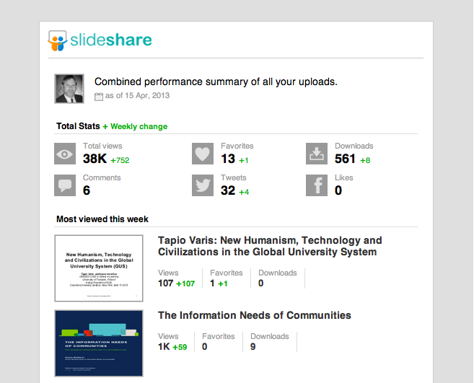
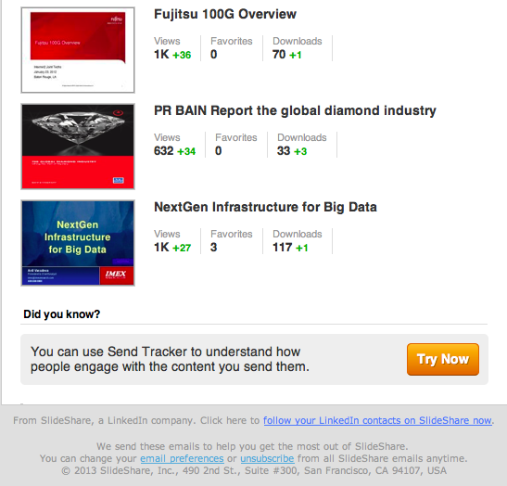

List of Distribution
John L. Mack, CEO
John L. Mack & Associates
International Telecommunications Investment Consultant
P.O. Box 567
Upper Marlboro, MD 20772-0567
301-627-2188
Cel: 240-535-4077
Fax: 301-627-2188
jlmack@comcast.net>
http://home.comcast.net/~jlmack/>
P. Tapio Varis, Ph.D., Professor
Acting President, Global University System
UNESCO Chair in Global e-Learning with applications to multiple domains
Professor and Chair of Media Education
Research Center for Vocational Education & Hypermedia Laboratory
University of Tampere
P.O.Box 229
FIN-13101 Hameenlinna
FINLAND
+358-3-3551-3608
Tel: +358-3-614-5608--office in Hameenlinna
Tel: +358-3-215 6243--mass media lab in Tampere
GSM: +358-50-567-9833
Fax: +358-3-614-5611 or +358-3-3551-3611
tapio.varis@uta.fi
tapio.varis@hamk.fi
tapio.varis@helsinki.fi
http://www.uta.fi/~titava
www.ecml-eu.org -- about ECML project.
http://www.uta.fi/conference/mediaskills/
prince gottfried and princess claudia windisch graetz
exec. producer,writer and directors of:
GLOBAL SATELLITE BROADCASTING FOR CULTURE;EDUCATION AND SCIENCE
INTERNATIONAL COMMUNICATIONS NETWORK
ECOLOGY AND ELECTRONIC ENVIRONMENT CORP
tele: OO49-07934-993724
das haeusle
am graben 6
97990 weikersheim
baden wurtemburg Germany
dashaeusle@t-online.de
Ms. Astrid Hogmo
Network Architect
Studiesenteret.no
Strandveien 6a
9350 Sjovegan
Norway
+47 99434031
astrid.hogmo@me.com
utstol@me.com
http://www.studiesenteret.no
Chief (Sir) Charles Ugo Eke
Founder/CEO
Infotechs Systems, LLC
312 Washington Str.
P. O. Box 22635
Newark, NJ 07102
908-405-7441
Fax: 973-242-4070
bychief@yahoo.com
www.infotexsystems.com
Hans Rudolf Herren, Ph.D.
President
Millennium Institute
1634 I St NW, Suite 300
Washington, DC 20006
cell + 1 530 867 4569
Tel 202 383 6200
Fax 202 383 6209
hansrherren@mac.com
hh@millennium-institute.org
www.millennium-institute.org
www.nourish9billion.org
http://www.biovision.ch/nc/en/home/
www.threshold21.com
http://www.biovision.ch
http://www.eduvision.or.ke
http://www.millenniuminstitute.net/
Greg Cole, Ph.D.
Principal Investigator
Global Ring Network for Advanced Applications Development (GLORIAD)
Director/Center for International Networking Initiatives (CINI)
Institute for a Secure and Sustainable Environment
311 Conference Center Bldg
University of Tennessee
Knoxville, TN 37996-4134
Cel: 865-309-5524
865‐974‐1262 – Greg’s phone.
865-974-2459
Fax: 865-974-1838
gcole@gloriad.org
gcole@friends-partners.org
http://www.gloriad.org/
http://issue.utk.edu/cini/
http://www.gloriad.org/gloriad/team/usa/gcole.html
http://www.friends-partners.org/
http://events.internet2.edu/speakers/speakers.php?go=people&id=1495 -- bio
http://www.friendspartners.org/GLOSAS/Global_University/Global%20University%20System/Cole's%20GLORAID/GLORIAD_update.pdf
or
http://makeashorterlink.com/?B3BD61B1B
http://www.sciencedaily.com/releases/2004/01/040102092834.htm
http://usinfo.state.gov/eap/Archive/2005/Apr/15-476539.html -- about GLORIAD
Funded by the US National Science Foundation, GLORIAD rings the northern hemisphere with an advanced optical Internet currently linking scientists, educators, and students in the USA, Russia, China, Korea, Canada, Netherlands, the five Nordic countries, Egypt, India, and Singapore.
Ed Dodds
Collaboration Strategist
Conmergence.com
PO Box 210735
Nashville, TN 37221-0735
(615) 657-9359
P: 615-4729-8744
F: 508-632-0370
blog.Conmergence.com
dodds@conmergence.com
skype: conmergence.labs, ed_dodds
gchat: conmergence.labs@gmail.com
http://www.diigo.com/user/ed_dodds
http://resume.linkedinlabs.com/4uhr2hnn
http://blog.conmergence.com/about-ed-dodds
http://blog.conmergence.com/work

*******************************************************************************
Takeshi Utsumi, Ph.D., P.E., Chairman
GLObal Systems Analysis and Simulation Association in the U.S.A. (GLOSAS/USA)
Laureate of Lord Perry Award for Excellence in Distance Education
Founder and V.P. for Technology and Coordination of Global University System (GUS)
43-23 Colden Street, #9L, Flushing, NY 11355-5913, U.S.A.
Tel: 718-939-0928; Cel: 646-589-1730; Skype: utsumi
Email: takutsumi0@gmail.com, Web: http://www.friends-partners.org/GLOSAS/
U.S./IRS Employer ID: 11-2999676 <http://tinyurl.com/534gxc
New York State Tax Exempt ID: 217837 <http://tinyurl.com/47wqbo>
Google Profiles <https://profiles.google.com/takutsumi0/about>
Facebook <http://www.facebook.com/GlobalEarlyWarningSystemsgews>
List Distribution <http://tinyurl.com/2fzx23e>
*******************************************************************************

